Capstone Project

James Bain

Introduction

## Purpose

* What is the problem or the opportunity that the project is investigating?
  + The project aims to provide users with a free, engaging and interactive experience reminiscent of the classic Trivial Pursuit board game. People don't always have time to play board games all the time.
* Why is this problem valuable to address?
  + Board games have wide appeal across all demographics. By making it digital it becomes more accessible.
* What is the current state (e.g. unsatisfied users, lost revenue)?
  + There may be unsatisfied users who enjoy traditional board games like Trivial Pursuit but face limitations in terms of finding opponents or playing on-the-go.
* What is the desired state?
  + The desired state is to have a fully functional and engaging Trivial Pursuit-style board game app available on digital platforms (e.g., iOS, Android) with features such as multiplayer modes, diverse question categories, customizable game settings, and seamless user experience.
* Has this problem been addressed by other projects? What were the outcomes?
  + Nothing has been a free to play version of the game. Which gives my project the advantage.

## Industry/ domain

* What is the industry/ domain?
  + The digital gaming industry is growing rapidly, driven by technological advancements and increasing demand for online and mobile gaming experiences.
* What is the current state of this industry? (e.g. challenges from startups)
  + Startups pose challenges in terms of competition for user engagement.
* What is the overall industry value-chain?
  + Game Development
  + Distribution Platforms
  + Monetization
  + Community and Social Engagement
  + Hardware
* What are the key concepts in the industry?
  + User Engagement
  + Monetization Strategies
  + Game Design
  + User Acquisition and Retention
  + Technology and Innovation
* Is the project relevant to other industries?
  + The project's focus on digital gaming intersects with industries like education as it is offering potential for gamified learning experiences.

## Stakeholders

* Who are the stakeholders? (be as specific as possible as to who would have access to the software)
  + Players/Users
  + Developers
  + Investors/Shareholders
* Why do they care about this software?
  + Players/Users: Seek entertainment and convenience.
  + Developers: Aim for success, positive feedback, and revenue.
  + Investors/Shareholders: Expect return on investment (ROI) and growth
* What are the stakeholders’ expectations?
  + Players/Users: Seamless, enjoyable experience.
  + Developers: Positive reception, revenue, and updates.
  + Investors/Shareholders: Expect return on investment (ROI) and growth

# Product Description

## User Stories

|  |  |  |  |  |
| --- | --- | --- | --- | --- |
| **#** | **User Story Title** | **User Story Description** | **Priority** | **Notes** |
| **1** | User Profile Update | As a registered user of the platform, I want to update my profile information, so that my account reflects accurate and up-to-date information about me. | High | Basic CRUD operation deployment |
| **2** | Start New Game | As a player, I want to initiate a new game from the main menu so that I can begin playing trivia. This feature should allow players to start fresh with a new game session, displaying the game board as soon as the new game is started. | High |  |
| **3** | Move Around the board | As a player, I want to roll a dice to determine my movement around the game board. This feature should enable players to progress in the game by moving their token/ to different spaces on the board. | High |  |
| **4** | Answer Trivia Questions | As a player, I want to encounter trivia spaces on the game board so that I can answer questions. This feature should present players with trivia questions when they land on specific spaces, allowing them to engage in the game's main mechanic of answering questions. | High |  |
| **5** | Track Score | As a player, I want to see my current score displayed on the game interface so that I can track my progress. This feature should dynamically update the player's score as they answer questions correctly or incorrectly, providing a visual representation of their performance. | High |  |
| **6** | Save Game | As a player I want to be able to leave a game and then return to it later. | High |  |

## User Flow and Wireframe Design

This is a link to my figma containing both user flow and wireframe design:

<https://www.figma.com/file/nr1Rq0fxCbdNc1vToqeQP1/Capstone-Project?type=design&node-id=0%3A1&mode=design&t=5JMQOd8iOlEP38b7-1>

## Open Questions/Out of Scope

* What features are considered out of scope?
  + Online play
  + 3D models
  + High end animations

## Non-functional Requirements

* How easy to use does the software need to be?
  + The software should be intuitive and user-friendly to appeal to a broad audience and encourage engagement. Clear navigation, intuitive interfaces, and responsive design contribute to a positive user experience.
* How quickly should the application respond to user requests?
  + The application should respond promptly to user requests to maintain user satisfaction and engagement.
* How reliable must the application be? (e.g. mean time between failures)
  + The application should be highly reliable, with minimal downtime and disruptions.
* Does the software conform to any technical standards to ease maintainability?
  + Adhering to technical standards, such as industry best practices and coding conventions

# Project Planning

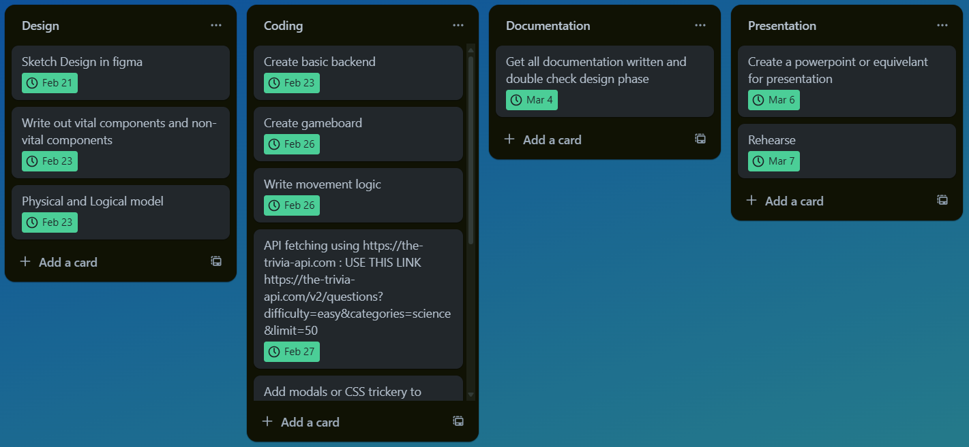Same picture with coding section scrolled down:

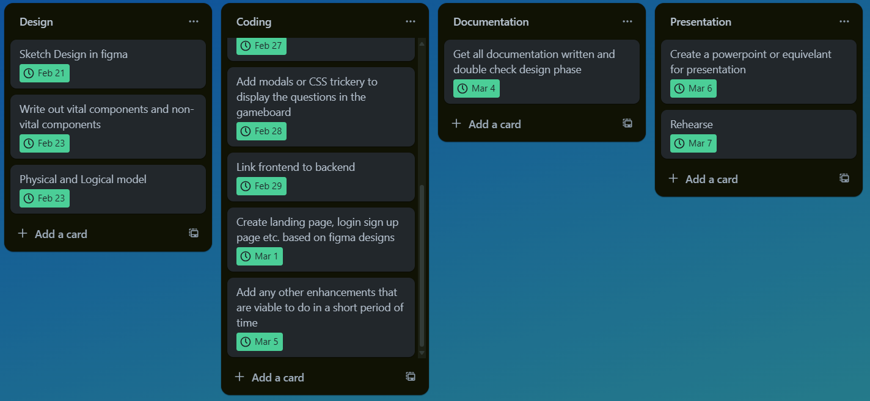

# Testing Strategy

* What steps were undertaken to achieve product quality?
  + Requirements Gathering
  + Design
  + Development
  + Testing (Unit, Functional)
  + User Feedback
* How was each feature of the application tested?
  + Either by functionally testing or unit testing
* How did you handle edge cases?
  + Identifying edge cases through user stories, and feedback from stakeholders.
  + Implementing features with robust error handling and validation to handle edge cases.

# Implementation

* What were the considerations for deploying the software?
  + Planned to deploy on AWS

# End-to-end solution

* How well did the software meet its objectives?
  + It met all the objectives that I thought were plausible
  + The enhancement list would be almost necessary for a full release. Due to the large and diverse market

# References

* Where is the code used in the project? (link to GitHub)
  + <https://github.com/JamesBain999/capstone-project.git>
* What are the resources used in the project? (libraries, APIs, databases, tools, etc.)
  + MySQL database
  + React app
    - ReactDOM
    - React-toastify
    - vitest
  + API: <https://the-trivia-api.com/v2>